**Assignment 1 – Object Orientation Concepts**

Total points: 27

Consider the following scenario and then answer the corresponding questions.

FitPalApp is a business that provides fitness programs and diet plans to customers. They are in the process of revamping their mobile application to manage subscribers and administer fitness programs and diet plans. The following requirements need to be met. The terms customer/ user/ subscriber can be used interchangeably. Similarly, the terms application/ system can be used interchangeably.

1. Customers will be allowed to register with the application by choosing credentials to login with, and provide contact information like name, date of birth, age, address, email and physical address, etc.
2. Upon successfully registering their accounts, customers will be presented with a health questionnaire online where they will answer questions that will assess their fitness level and goals. The questionnaire will capture information like their current weight, height, age, etc., to assess the BMI, fitness and body fat levels. The system will generate a graphics/ charts showing the fitness levels visually.
3. After the health questionnaire is completed, the customers will be presented with another questionnaire to assess their goals. Customers will answer questions like what they would like their target weight to be, how soon they want to accomplish the goal, how often they are willing to exercise in a week, how much time they want to spend on their workouts and what type of workout (aerobics, yoga, strength training, etc.) would they be interested in.
4. The system will capture additional information like any health conditions the customer has or any medications the customer is currently taking, and any past medical history, which can be used to customize the diet and workout plans. Customers will be asked to sign an agreement, accept terms and conditions, releasing the company of any liabilities or claims.
5. There are two types of customers: Basic customers, who do not pay any subscription fee to use the app. They will be able to create their profile, complete all the questionnaires and accept terms and conditions. They will be able to view free workout plans and basic diet plans.
6. The app will offer advanced features to subscribers, who will pay a fee to use the app. The system offers two types of subscription plans – Gold and Platinum.
   1. Gold subscribers will be able to view paid workout routines and diet plans.
   2. Platinum subscribers will be able to work with a personal trainer and dietician to customize workout and diet plans.
   3. Both types of subscribers will be able to like and make a favorite list of recipes, diet plans and workouts.
   4. Both types of subscribers will be able to export the data from the system into a excel file. Additionally, platinum customers will be able to invite their doctors or other healthcare providers (external to our system) to view the data logged by them. This external integration with their health care providers will not be available to basic or gold members.
      1. For this external integration to work, health care providers will have to create an account and register themselves as a provider. This is a different workflow that will allow providers to register for an account and connect with their patients. There is no charge for the providers.
         * Providers will provide their name, address, date of birth, medical license #, hospital affiliation, provider #, etc during registration.
         * They will create an account identifying themselves as a provider.
         * Patients will be able to search for a provider and share their logs directly with the providers.
   5. The subscription price will vary depending on the type of contract and the system will apply the correct pricing depending on the plan chosen.
   6. Once the user opts for subscription, user will be shown a contract with all the details about the subscription and the premium features that will be offered, and additional terms and conditions.
7. Users should be able to make payments via the app, view receipt for past payments, log their daily diet and workouts, weight and other health vitals. The system will keep track of their progress and generate graphics/ charts displaying the progress towards the goal on a weekly, monthly, or quarterly basis. Users will also be able to generate graphs based on a custom date range.
   1. Users will be requested to add their credit card details when opting for a subscription. Users can opt for auto or manual renewal.
   2. Prior to the expiration of the subscription, all subscribers will receive an email notification about the end of their subscription, 2 weeks prior to the expiration date. If users have opted for auto payment, the email will remind them about an automatic payment at the end of the cycle.
   3. The system will apply automatic payment for those users that opted for auto-payment 2 days prior to when the subscription ends.

Upon your review complete the following:

1. Identify **all major classes** that could be part of the system. **For each class** identify some major attributes and operations (**5-8 attributes and 5-8 operations**). Your classes should be represented using proper object modeling notation (UML notation/ boxes for classes). Refer to slides for the format expected. We have discussed this in a practice case in class. (20 pts)
   1. *This is your case study for individual assignment for the entire semester. You are just exploring this topic. So, you are not expected to draw a class diagram (for those familiar with OO models). You are just listing the classes in UML format.*
   2. *This is just your first assignment and you are not required to list all methods and attributes this time.*
   3. *You will do detailed analysis later during the semester, where you will describe the attributes and operations in more detail and add more classes. For now, it is sufficient to list all the major classes and identify 4 attributes and 4 operations.*
   4. **“Where can I generally go wrong?”:** Wrong UML Notations, Wrong Class Names, irrelevant classes, Missing few major classes, not using proper attribute/ method names and following naming convention, not using visibility indicator, not defining data type for attributes, defining attributes and methods that are not relevant for a class, mixing up attributes belonging to other entities.
      1. **Relevance** is absolutely important. For example: Customer Class for an airline reservation system is not the same a Customer class for an ecommerce system. The characteristics of customers between these two systems are vastly different. Just because a Customer class has been identified, you will not get credit unless that class is described properly with relevant attributes and operations.
      2. **Clarity** is important. Remember, you are the analyst and you are going to hand this over to the development team for design and implementation. If you do not convey your thoughts clearly, how can they build it? An item in the shopping card in an ecommerce application is about products, while, an itinerary in the shopping cart in an airline reservation system is a reservation. You cannot have a Shopping cart class and have irrelevant or unclear information. Your class name, attribute names, method names, must help a novice reader to understand what you are trying to communicate. This is important and you must demonstrate that you understand these concepts in your responses.

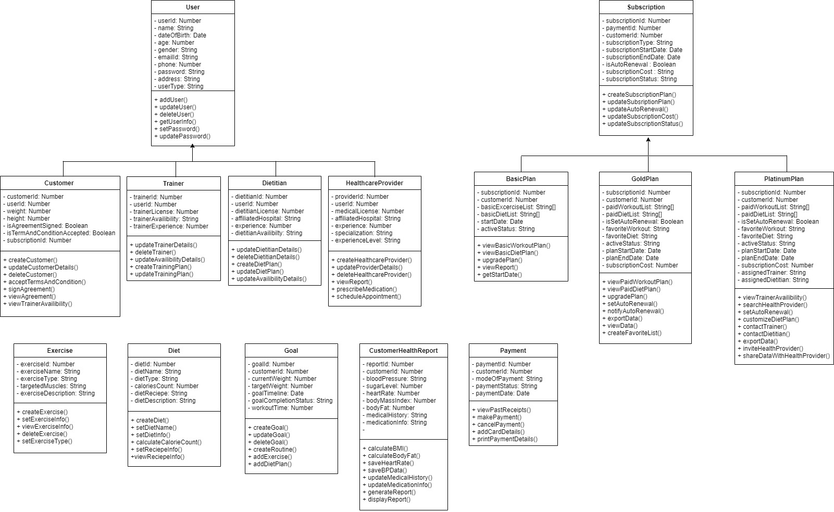

1. For **each class** identified in question 1, list any states that may be associated with that class. (Hint: State is the condition of an object at a certain stage in its lifetime. (5 pts)
2. User: Customer, dietitian, trainer, healthcare provider (Based on userType attribute)
3. Customer: Yes or no (based on isAgreementSigned attribute), yes or no (based on isTermAndConditionAccepted attribute)
4. Trainer: available, busy (based on trainerAvailibility attribute)
5. Dietitian: available, busy (based on dietitianAvailibility attribute)
6. HealthcareProvider: beginner, intermediate, expert (based on experienceLevel attribute)
7. Subscription: basic, gold or platinum (based on subscriptionType attribute)
8. BasicPlan: active or expired (based on activeStatus attribute)
9. GoldPlan: yes or no (based on isSetAutoRenewal attribute)
10. PlatinumPlan: yes or no (based on isSetAutoRenewal attribute)
11. Exercise: aerobic, yoga, strength training (based on exerciseType attribute)
12. Diet: vegetarian, non vegetarian, vegan (based on dietType attribute)
13. Goal: started, intermediate, achieved ( based on goalCompletionStatus attribute)
14. CustomerHealthReport: high, low, normal (based on bloodPressureLevel attribute)
15. Payment: initiated, inprocess, declined, canceled ( based on paymentStatus attribute)
16. Are there any superclasses or subclasses in your model? If so, list them and show their relationship. If not, **explain your reasoning**. Answers without explanation will not receive credit. (2 pts)

* **Superclass**: User, **Subclass**: Customer, Trainer, Dietitian and Healthcare Provider

**Healthcare Provider**

**Dietitian**

**Trainer**

**Customer**

**User**

* **Superclass**: Subscription, **Subclass**: Basic Plan, Gold Plan, Platinum Plan

**Gold Plan**

**Basic Plan**

**Subscription**

**Platinum Plan**

* **Superclass**: Payment, **Subclass**: Credit card, Gift card, Paypal

**Paypal**

**Giftcard**

**Credit Card**

**Payment**

* **Superclass**: Exercise, **Subclass**: Aerobic, Yoga, Strength Training

**Yoga**

**Aerobic**

**Exercise**

**Strength Training**

* **Superclass**: Diet Type, **Subclass**: Vegeterian, Non Vegeterian, Vegan

**Vegan**

**Vegeterian**

**Diet Type**

**Non Vegeterian**